5. FLUID DYNAMICS
BERNOULLI’S EQUATION:
$$\sum{F_{s}}=m a_{s}$$  Forces acting on the fluid element shown in the figure,  $F_{g}=$ Gravitational Force $F_{P}=$ Pressure Force  $F_{V}=$ Viscous Force $F_{T}=$ Turbulent Force  $F_{S}=$ Surface Tension Force $F_{C}=$ Compressible Force  $${\left(F_{g}+F_{P}+F_{V}+F_{T}+F_{S}+F_{C}\right)}_{s}=m a_{s}$$  $$∴{\left(F_{g}+F_{P}+F_{V}+F_{T}\right)}_{s}=m a_{s} (Reynold^{'}s Equation)$$  $$∴{\left(F_{g}+F_{P}+F_{V}\right)}_{s}=m a_{s} (Navier-Stoke^{'}s Equation)$$  $$∴{\left(F_{g}+F_{P}\right)}_{s}=m a_{s} (Euler^{'}s Equation)$$ |  | 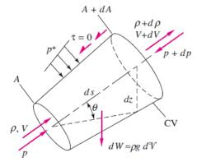
$$∴-dW\sin{θ}+P dA-\left(P+\frac{∂P}{∂s}ds\right)dA=dm a_{s}⇒-γ d∀\frac{dz}{ds}- \frac{∂P}{∂s}ds dA=ρ d∀ V_{s}\frac{∂V_{s}}{∂s}$$
$$\left(∵\sin{θ}=\frac{dz}{ds}\& a_{s}=\frac{∂V_{s}}{∂t}+V_{s}\frac{∂V_{s}}{∂s}=V_{s}\frac{∂V_{s}}{∂s} \left(Steady Flow\right) \& d∀ =ds dA\right)$$
$$\frac{dP}{ρ}+V_{s}dV_{s}+g dz=0 (Euler^{'}s Equation)$$ | $$\int{\frac{dP}{ρ}}+\frac{V^{2}}{2}+gz=Const.\left(Bernoulli^{'}s Eq. For Steady Flow\right)$$
Bernoulli’s Eq. For Steady and incompressible Flow,  $$Pressure Head+Kinetic Head+Potential or Datum Head=Total Head=Const.$$ |  |  | $$\frac{P}{ρg}+\frac{V^{2}}{2g}+z=H$$
- Net mechanical energy of fluid in an ideal flow remains constant.
VARIOUS FORMS OF BERNOULLI’S EQUATION:
Energy Per unit mass,  $$\frac{P}{ρ}+\frac{V^{2}}{2}+gz=Constant$$ |  |  | Energy Per unit Volume,  $$P+ρ\frac{V^{2}}{2}+ρgz=Constant$$
$P=$ Static Pressure |  | $ρ\left({V^{2}}/2\right)=$ Dynamic Pressure (Rise in pressure due to drop in K.E.) |  | $ρgz=$ Hydrostatic Pressure (Rise in pressure due to drop in P.E.)
Energy Per unit weight,$$\frac{P}{γ}+\frac{V^{2}}{2g}+z=Constant$$ | At stagnation point, Stagnation Pressure = Static Pressure + Dynamic Pressure  Piezometric Pressure = Static Pressure + Hydrostatic Pressure

LIMITATIONS/ ASSUMPTIONS IN BERNOULLI’S EQUATION
- Flow is Steady.  - Incompressible Flow.  - Heat Transfer effects are neglected.  - In Irrotational Flow, B. Eq. is valid across any two stream line but for Rotational flow, B. Eq. is valid only along stream line not across the stream line. | - Involvement of shaft work (Pump & Turbine): Heads need to balance when energy per unit mass is added or removed. E.g. Pump is adding head & turbine is Using head to gain shaft work.  - Valid only for ideal flow. But by introducing head loss, we can use the B. Eq. for real flow.
HEAD LOSS: Energy given by the fluid to overcome resistance against the flow per unit weight is called head loss.
NOTE: In the absence of a pump, Real flow takes place from higher total head to lower total head.
KINETIC ENERGY CORRECTION FACTOR ($α$):
When the velocity profile is non uniform, Total velocity head and avg. velocity head are not equal.
Local Velocity = $u$& Avg. Velocity = $V$
$$d\left(\dot{KE}\right)=\frac{1}{2}d\dot{m} u^{2}⇒\dot{KE}=\frac{1}{2}\iint{u^{3}dA}$$ | $$\dot{KE}=α\frac{1}{2}ρAV^{3}$$ | $$α=\frac{1}{AV^{3}}\iint{u^{3}dA}$$
Always $α≥1$  For uniform Flow $α=1$ | For Laminar Flow through pipe $α=2$ | For turbulent flow through pipes, $1.1≤α≤1.3$

DIFFERENCE IN PIEZOMETRIC HEAD:  $$P_{A}=P_{B}⇒P_{1}+γ_{w}z_{1}=P_{2}+γ_{w}\left(z_{2}-h_{m}\right)+γ_{m}h_{m}$$  $$∴∆P^{*}=h_{m}(γ_{m}-γ_{w})$$  $$∴∆h^{*}=h_{m}\left(\frac{γ_{m}}{γ_{w}}-1\right)=h_{m}\left(\frac{S_{m}}{S_{w}}-1\right)$$ $$S_{m}≫S_{w}⇒∆h^{*}=h_{m}\left(\frac{S_{m}}{S_{w}}\right)$$ | 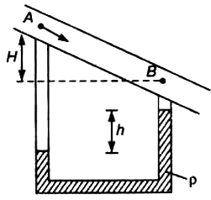
EQUATION OF POWER: $P\left(in J\right)=hρgQ \& P\left(in W\right)=hρg\dot{Q}$
FREE LIQUID JET:  $$u=V\cos{θ}$$ $$v=V\sin{θ}$$ $H=$ Max. Height $T=$ Time of Flight  $$s=ut+\frac{1}{2}at^{2}$$ $$x=V\cos{θ} t$$ $$y=V\sin{θ} t+\frac{1}{2}\left(-g\right)t^{2}$$  From above both equations,  $$y=x\left(\tan{θ}\right)-\left(\frac{g\sec^{2}{θ}}{2 V^{2}}\right)x^{2}(Parabolic Eq.)$$ |  | 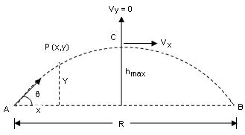
$$H=\frac{V^{2}\sin^{2}{θ}}{2g}=\frac{v^{2}}{2g}(∵V^{2}-U^{2}=2aS)$$ | $$T=\frac{2v}{g}(∵V=U+at \& T=t_{a}+t_{d})$$ |  | $$R=\frac{2uv}{g}$$

VELOCITY MEASUREMENT | $$\frac{V^{2}}{2g}=H-h^{*}$$

- PITOT TUBE + PIEZOMETER:  $$h_{stag}=\frac{P}{γ}+\frac{V^{2}}{2g}$$ $$h_{stat}=\frac{P}{γ}$$ $$h^{*}=h_{stat}+z$$ $$H=h_{stag}+z$$  From above equations, we can find velocity head or velocity in the pipe.  $$V_{th}=\sqrt{2g\left(H-h^{*}\right)}=\sqrt{2gh} (From the Fig.)$$  $$Coefficient Of Velocity or Prob Factor C_{V}=\frac{Actual Velocity}{Theoretical Velocity}$$  $$V_{act}=C_{V}\sqrt{2g\left(H-h^{*}\right)}=C_{V}\sqrt{2gh}$$  It can’t use for gaseous fluid. | 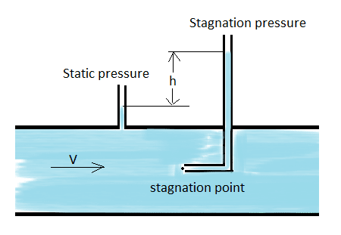
NOTE: If $C_{V}$ is not give, $C_{V}=1$.
- PITOT-STATIC TUBE:  $$V_{th}=\sqrt{2g∆h^{*}}$$  From the previous derivations,  $$V_{act}=C_{V}\sqrt{2g{ h}_{m}\left(\frac{S_{m}}{S_{w}}-1\right)}$$ | 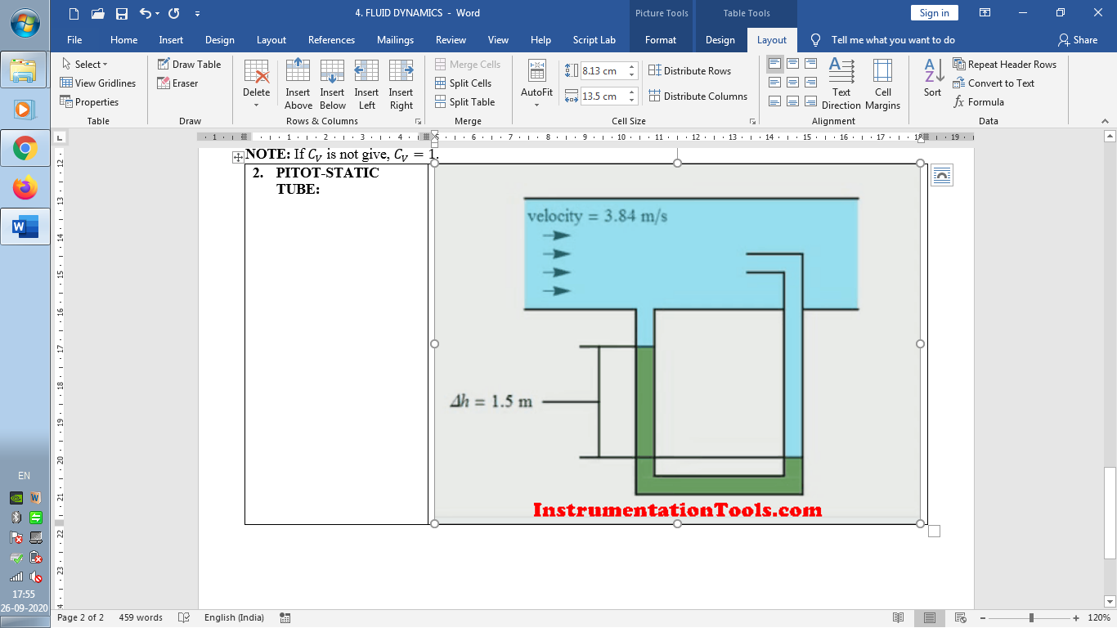
DISCHARGE/ FLOW MEASUREMENT:
OBSTRUCTION FLOWMETER: E.g. Orifice Meter, Venturi Meter, Nozzle Meter.
Head-loss in Obstruction Flowmeter:  $${\left(\frac{P}{γ}+\frac{V^{2}}{2g}+z\right)}_{1}={\left(\frac{P}{γ}+\frac{V^{2}}{2g}+z\right)}_{2}+h_{l}⇒h_{l}=∆h^{*}-\left(\frac{V_{2}^{2}-V_{1}^{2}}{2g}\right)$$  From the mass conservation in incompressible flow,  $$h_{l}=∆h^{*}-\frac{V_{2}^{2}A_{2}^{2}}{2g ∆h^{*}}\left(1-\frac{A_{2}^{2}}{A_{1}^{2}}\right)\frac{∆h^{*}}{A_{2}^{2}}=∆h^{*}-\frac{Q_{act}^{2}}{Q_{th}^{2}}∆h^{*}$$  $$∴h_{l}=∆h^{*}(1-C_{d}^{2})$$  $$Q_{act}^{2}=V_{2}^{2}A_{2}^{2}$$ $$Q_{th}^{2}=2g ∆h^{*}\left[{A_{1}^{2}A_{2}^{2}}/{\left(A_{1}^{2}-A_{2}^{2}\right)}\right]$$ | 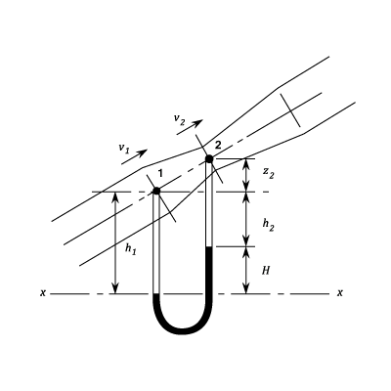
VENTURI METER:  $$h_{l}=∆h^{*}(1-C_{d}^{2})$$  $$Q_{act}^{2}=V_{2}^{2}A_{2}^{2}$$ $$Q_{th}^{2}=2g ∆h^{*}\left[{A_{1}^{2}A_{2}^{2}}/{\left(A_{1}^{2}-A_{2}^{2}\right)}\right]$$  By Considering $h_{l}=0,$  $$∆h^{*}=\frac{V_{2}^{2}}{2g}\left(1-\frac{A_{2}^{2}}{A_{1}^{2}}\right)⇒V_{2}=\frac{A_{1}}{\sqrt{A_{1}^{2}-A_{2}^{2}}}\sqrt{2g ∆h^{*}}$$  $$Q_{th}=\frac{A_{1}A_{2}}{\sqrt{A_{1}^{2}-A_{2}^{2}}}\sqrt{2g ∆h^{*}}⇒Q_{th}=Q_{act}$$ | 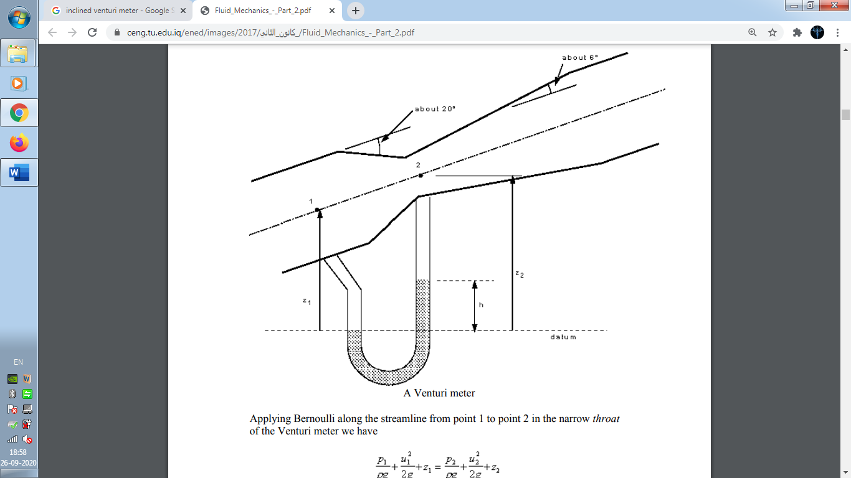
$Q_{th}$ equation is same for all measuring device.
$$Coefficient of Discharge, C_{d}=\frac{Q_{act}}{Q_{th}}$$ | $$Coefficient of Contraction, C_{c}=\frac{A_{c}}{A_{2}}=\frac{V_{2}}{V_{c}}$$
In Venturi Meter, To Reduce Minor Losses in Diffuser, Converging Angle $\left(20°\right)>$ Divergence Angle $\left(7° to 15°\right)$
$$PART-I:\frac{A_{1}A_{2}}{\sqrt{A_{1}^{2}-A_{2}^{2}}}=\frac{π}{4}\frac{D_{1}^{2}D_{2}^{2}}{\sqrt{D_{1}^{4}-D_{2}^{4}}}$$ | $$PART-II:\sqrt{2g ∆h^{*}}⇒∆h^{*}={ h}_{m}\left(\frac{S_{m}}{S_{w}}-1\right)=\frac{∆P^{*}}{γ}$$

 | Venturi Meter | Nozzle Meter | Orifice Meter
$$C_{d}$$ | 0.95-0.98 (High) | 0.85 (Medium) | 0.65 (Low)
$$h_{loss}$$ | Low | Medium | High
Accuracy | High | Medium | Low
Cost | High | Medium | Low
VORTEX MOTION: It’s motion of fluid along a curved path is known as vortex motion.
E.g. Whirlpool, Tornado, Water Sink, etc…

- $V_{r}=0, V_{θ}$ exists.
- Stream Lines are curved.

TYPE OF VORTEX FLOW
FREE VORTEX FLOW | FORCED VORTEX FLOW
It’s naturally (By the virtue of motion itself) exists. | Appling external torque for generating Vortex flow.
External Torque is equal to zero. | Constant External Torque is applied.
$$T=0⇒\frac{d\left(mv r\right)}{dt}=0⇒mv r=Constant$$ | Angular Velocity of every partial is same.  $$T=Const. ⇒ω=Const.⇒ v∝r$$
Singularity Point: $r=0⇒v=not defined$ | $$r=0⇒v=0$$
Flow is irrotational. E.g. Bernoulli’s equation can be applied between any point. | Flow is rotational. E.g. Bernoulli’s equation can be applied between any point lying on same stream lines.
Valid for any 2 random points,  $$\frac{P_{A}}{γ}+\frac{V_{A}^{2}}{2g}+z_{A}=\frac{P_{B}}{γ}+\frac{V_{B}^{2}}{2g}+z_{B}$$ | Valid for any 2 random points,$$\frac{P_{A}}{γ}-\frac{V_{A}^{2}}{2g}+z_{A}=\frac{P_{B}}{γ}-\frac{V_{B}^{2}}{2g}+z_{B}$$

RANKINE VORTEX MOTION: Vortex Motion having a combination of free vortex & forced vortex.
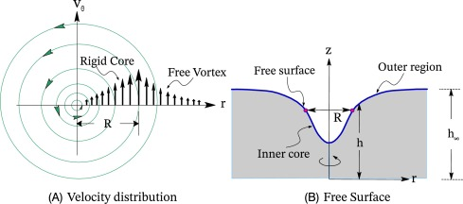
EQUATION OF PRESSURE:
$$dP=\frac{∂P}{∂r}dr+\frac{∂P}{∂z}dz (∵P=f(r,z))$$  $$dm=ρdAdr$$ $$a_{r}=rω^{2}$$  From the figure, $\sum{F_{r}}=m a_{r}$  $$\frac{∂P}{∂r}drdA=dm a_{r}$$  $$\frac{∂P}{∂r}=ρω^{2}r$$ $$\frac{∂P}{∂z}=-ρg$$  $$∴dP= ρω^{2}r dr-ρg dz=ρ \left(a\right) dl$$ | 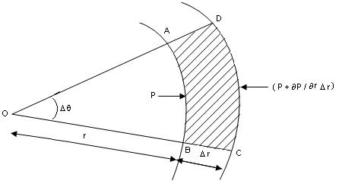
Note: Forced Vortex Flow is Part of Rigid Body Motion.
FREE VORTEX FLOW | FORCED VORTEX FLOW
$$v r=r^{2}ω=C$$ | $$v=C r⇔ω=Const.$$
$$\frac{P_{A}}{γ}+\frac{V_{A}^{2}}{2g}+z_{A}=\frac{P_{B}}{γ}+\frac{V_{B}^{2}}{2g}+z_{B}(From dP Eq.)$$ | $$\frac{P_{A}}{γ}-\frac{V_{A}^{2}}{2g}+z_{A}=\frac{P_{B}}{γ}-\frac{V_{B}^{2}}{2g}+z_{B}(From dP Eq.)$$
Hence, the flow is irrotational. | Hence, the flow is rotational.
EQUATIONS OF ISOBAR: Constant pressure imaginary curve in vortex (Forced) flow.
$$\frac{P_{A}}{γ}+\frac{V_{A}^{2}}{2g}+z_{A}=\frac{P_{B}}{γ}+\frac{V_{B}^{2}}{2g}+z_{B}⇒h=\frac{V_{B}^{2}-V_{A}^{2}}{2g}=\frac{r^{2}ω^{2}}{2g}∝r^{2}\left[\begin{aligned}∵z_{A}-z_{B},V_{A}=0,V_{B}=rω \\ It^{'}s Parabolic Curve\end{aligned}\right]$$
VOLUME OF PARABOLOID: Volume of revolution of parabola. E.g. Circumscribing cylinder with parabola.
Circumscribed refers to a shape surrounding another shape. | $$∀_{par.}=\frac{πω^{2}}{g}\frac{R^{4}}{4}=\frac{1}{2}∀_{cyl.}(∵r_{max}=R)$$

